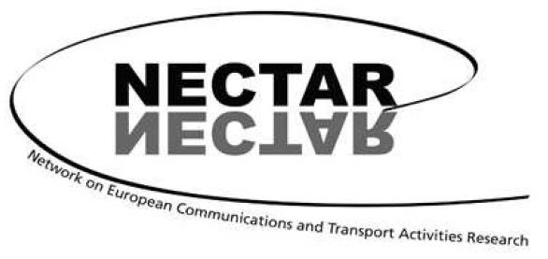

18th International NECTAR Conference
Munich, Germany, 13 -15 July 2026

Call for Papers for the thematic session of Cluster 5:
Leisure, Recreation and Tourism

Planning for Urban Tourism Mobility towards Sustainability and Efficiency

One of the key challenges in advancing sustainable urban tourism is understanding the complex interrelationship between transportation and tourism. Transportation plays a crucial role in shaping the efficiency, patterns, and volume of urban tourism. To move toward sustainability, cities must encourage modal shifts to environmentally friendly transport options and improve intermodal connectivity. Moreover, spatial localizing, restructuring, coordinated land use, and transport planning should interact to reduce the demand for mobility. Research has shown how urban transport systems influence tourist satisfaction, transport mode choices, spatial movements, and how good connections among different transport modes enhance tourist satisfaction in terms of cost, time, safety, comfort, accessibility, and convenience.
Public policies and planning are essential for promoting sustainability, and without them, there is a risk of jeopardizing virtuous circles of development. Such policies may relate to the financing and building of transport infrastructures that promote the use of environmentally friendly transport options. They may also include schemes to incentivize the use of sustainable transport options by tourists. In this context, it is necessary to move from an adaptive resilience, which counters the effects of negative phenomena once they have already occurred, to a planned resilience, which forecasts all possible episodes and assumes all necessary means to minimize their effects. Moreover, the availability of reliable information and the ability to forecast future demand trends are necessary prerequisites for the efficient, effective, and sustainable management of tourism transport in urban settings.
The cluster session explores how urban tourism transport planning can support the development of tourism towards sustainability and efficiency. We welcome papers that address this theme broadly and invite contributions discussing the following specific topics:
- innovations and advancements in urban tourism transport planning,
- involvement of stakeholders in tourism transport planning,
- quantitative and qualitative methods to assess the impact of urban tourism transport planning on sustainability and efficiency,
- synergies between residents and visitors for the development of innovative and sustainable urban tourism transport services and infrastructures,
- the role of destination management organizations (DMO) or other institutions in coordinating the transport and mobility of tourists,
- forecasting tourist mobility demand in times of uncertainty (e.g., seasonal fluctuations, global crises),
- GIS and spatial analysis tools for mapping tourist flows and transport needs in cities, and
- use of big data in urban tourism transport analysis and planning.

Deadline for abstract submission
The deadline for abstract submission is January 31, 2026. Abstracts (max. 500 words) should be submitted electronically, using the form available on the conference website and following the instructions found there: https://nectar26.eu/

A copy of the abstract should also be sent to the cluster co-chairs Luca Zamparini (luca.zamparini@unisalento.it) and Janika Raun (janika.raun@ut.ee).

Criteria for acceptance
Criteria for acceptance are scope, scientific quality, NECTAR membership, and the possibility of fitting the presentation into a coherent conference session. The number of participants in this thematic session will be limited to 8.

Venue
NECTAR 2026 will be hosted by the Accessibility Planning Research Group at the Chair of Urban Structures and Transport Planning, Technical University of Munich (TUM), in collaboration with the NECTAR Board and its thematic clusters.

Participation and NECTAR membership
Registration, and meals will be offered to NECTAR members, for only one author per paper. All practical details will be communicated through the conference website. In order to participate in the conference, a consecutive and current two-year NECTAR membership is necessary (2026-2027). Non-members can find details of how to join the association on the “Membership” page of NECTAR’s website: www.nectar-eu.eu/membership.

Important dates
Abstract submission: January 31, 2026
Notification of acceptance: April 1, 2026
Confirmation of attendance: April 30, 2026

We look forward to seeing you in Munich!

Janika Raun, Cluster 5 co-chair, University of Tartu, Tartu, Estonia
Luca Zamparini, Cluster 5 co-chair, University of Salento, Lecce, Italy
Peter Nijkamp, Cluster 5 co-chair, Open University, Heerlen, The Netherlands
João Romão, Cluster 5 co-chair, Yasuda Women’s University, Hiroshima, Japan

NECTAR is a European-based scientific association. The primary objective is to foster research collaboration and exchange of information between experts in the field of transport, communication and mobility from all European countries and the rest of the world. It is a multidisciplinary social science network bringing together a wide variety of perspectives on transport and communication problems and their impacts on society from an international perspective. For further information on NECTAR, use the link: http://www.nectar-eu.eu.

