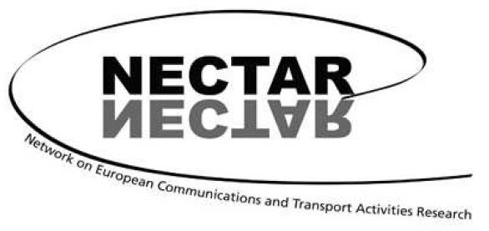

18th International NECTAR Conference
Munich, Germany, 13 - 15 July 2026

Call for papers for the thematic session of Cluster 4: Urban Mobility transitions

Cluster 4 explores the evolving landscape of urban mobility transitions within the broader context of transition economies. Our focus is on developing and advancing methods, techniques, and processes that support and accelerate the shift toward sustainable mobility in diverse urban environments. We critically examine the challenges to change, including resistance and backlash, while seeking out the motivations and opportunities that drive progress. Our work is rooted in an interdisciplinary perspective, integrating insights from mobility innovations (beyond technology), governance, mobility cultures, public policies—especially land use—and transport justice. Collaboration across disciplines and sectors is central to our approach, fostering transformative change in urban mobility

Submissions for the Nectar Cluster 4 thematic session are invited in the following topics (but not limited to):
- Street experiments and mobility transitions
- New narratives and compelling stories to inspire change in urban mobility.
- Evidence of new mobility cultures among young generations.
- Behavioural, social, and digital transitions, including teleworking.
- The role of accessibility conditions in sustainable transitions.
- Modal shift and behaviour, promoting sustainable transport modes.
- Equity, fairness, and social issues, addressing urban inequalities.
- Multilevel governance and stakeholder collaboration.
- Governance structures supporting transformative capacity.
- Citizen involvement in mobility projects.
- Innovative solutions and experimentation in mobility.
- Micro-mobility and stakeholder engagement.
- Sustainable shared mobility practices.

Deadline for abstract submission
The deadline for abstract submission is January 31, 2026. Abstracts (max. 500 words) should be submitted electronically, using the form available on the conference website and following the instructions found there: https://nectar26.eu/

Criteria for acceptance
Criteria for acceptance are scope, scientific quality, NECTAR membership and the possibility to fit the presentation in a coherent conference session. The number of participants of this thematic session will be limited to 8.

Venue
NECTAR 2026 will be hosted by the Accessibility Planning Research Group at Chair of Urban Structures and Transport Planning, Technical University of Munich (TUM), at the Technical University of Munich, in collaboration with the NECTAR Board and its thematic clusters.

Participation and NECTAR membership
All practical details will be communicated through the conference website. In order to participate in the conference, a consecutive and current two-year NECTAR membership is necessary (2024-2026). Non-members can find details of how to join the association on the “Membership” page of NECTAR’s website: www.nectar-eu.eu/membership

Important dates
Abstract submission: January 31, 2026
Notification of acceptance: April 1, 2026
Confirmation of attendance: April 30, 2026

We look forward to seeing you in Munich!

Alejandro Tirachini, Cluster 4 co-chair, University of Braunschweig, Germany
John Östh, Cluster 4 co-chair, Oslo Metropolitan University, Norway
Cecília Silva, Cluster 4 co-chair, University of Porto, Portugal
Olivier Bonin, Cluster 4 Co-chair, Université Gustave Eiffel, France

NECTAR is a European-based scientific association. The primary objective is to foster research collaboration and exchange of information between experts in the field of transport, communication and mobility from all European countries and the rest of the world. It is a multidisciplinary social science network bringing together a wide variety of perspectives on transport and communication problems and their impacts on society from an international perspective. For further information on NECTAR, use the link: http://www.nectar-eu.eu.

